Rich Goodier April 8, 2025
BINF 6310

Final Project: Individual Write-up

Introduction
The paper, "Single-Cell Transcriptome Profiling of Human Pancreatic Islets in Health and Type 2 Diabetes" by Segerstolpe et al. (2016), presents a detailed investigation into the transcriptional profiles of individual pancreatic cells in both healthy and Type 2 diabetic (T2D) donors using single-cell RNA sequencing (scRNA-seq) (p. 593). This approach facilitated the identification of distinct cell subpopulations within pancreatic islets and highlighted gene expression variations linked to diabetes and obesity (p. 594).

Historically, understanding the cellular mechanisms underlying diabetes has been complicated by pancreatic islets' cellular heterogeneity, hindering detailed interpretations from bulk RNA sequencing (p. 594). Pancreatic islets consist primarily of endocrine cells—alpha (α), beta (β), gamma (γ), delta (δ), and epsilon (ε)—each producing distinct hormones vital for metabolic homeostasis. The authors addressed the challenge of cellular complexity by employing high-throughput single-cell transcriptomics, enabling a precise analysis of individual cellular responses within pancreatic islets (p. 595).

Statement of Need
The necessity of this research is due to the incomplete understanding of pancreatic endocrine cell biology at a molecular level, particularly how these cells respond to pathological states such as diabetes and obesity (p. 593). Previous transcriptomic studies have lacked the resolution to differentiate between changes in cell types and actual transcriptional alterations within specific cell types (p. 595). Thus, the study sought to fill this gap by offering a granular view of gene expression dynamics across pancreatic cell types in both healthy and diabetic states.

Initial Hypothesis
Segerstolpe et al. hypothesized that single-cell RNA-seq would uncover distinct transcriptional profiles and novel subpopulations within pancreatic islet cells, revealing specific molecular signatures associated with T2D and obesity. This hypothesis was substantiated by their findings, which confirmed the existence of subpopulations within major endocrine cells—particularly α and β cells—and identified unique transcriptional alterations correlated with obesity (BMI) and diabetes (p. 596-597).

Corroboration
To support their findings, the authors provided corroborating evidence through differential gene expression analysis and validation experiments, such as fluorescence in situ hybridization (FISH). For instance, they validated leptin receptor (LEPR) co-expression with somatostatin (SST) in δ-cells, suggesting a previously unrecognized role in metabolic regulation (p. 597). They also found significant correlations between gene expressions such as PCSK1N, involved in hormonal regulation, and BMI, emphasizing the connection between obesity and endocrine dysfunction (p. 600-601).

The methodology of the study, particularly the use of the Smart-seq2 protocol, was robust and valid, offering comprehensive, high-quality transcriptome data with sensitivity and accuracy suitable for analyzing rare cell types. Moreover, they performed extensive quality control measures, which bolstered the validity of their results (p. 594-595).

Drawbacks and Oversights
Despite its strengths, the study overlooked potential impacts which could influence gene expression independent of disease states. Firstly, the whole of T2D donors were deceased while the healthy donors were alive at the moment of cell-harvesting. Secondly, the human pancreatic islets were cultured for about four days after isolation to allow for recovery (p. 595). Such stresses could affect gene expression and alter results downstream. Additionally, the study did not deeply explore the influence of age and sex as biological variables, which could impact gene expression patterns significantly in the pancreas (p. 600).

Conclusion
Overall, this widely-regarded seminal work by Segerstolpe et al. significantly advances the understanding of pancreatic biology, providing a foundation for future studies targeting cellular and molecular mechanisms underlying diabetes and metabolic diseases. Future investigations, however, would benefit from addressing the identified oversights by incorporating more extensive demographic analysis and minimizing donor and culture-related transcriptional alterations.

Graphical Abstract
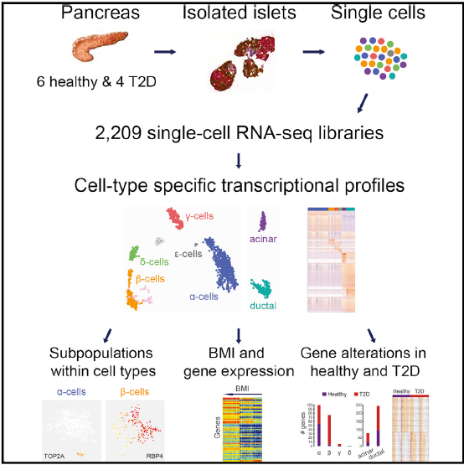

Reference
Segerstolpe, Å., Palasantza, A., Eliasson, P., Andersson, E. M., Andréasson, A. C., Sun, X., Picelli, S., Sabirsh, A., Clausen, M., Bjursell, M. K., Smith, D. M., Kasper, M., Ämmälä, C., & Sandberg, R. (2016). Single-Cell Transcriptome Profiling of Human Pancreatic Islets in Health and Type 2 Diabetes. Cell metabolism, 24(4), 593–607. https://doi.org/10.1016/j.cmet.2016.08.020

